C6_3

setwd(".")  
library(knitr)

Apartado a)

setwd(".")#700 1100 10 900  
library(knitr)  
limsup<-900+150  
liminf<-900-150  
prob<-0.99  
mu<-900  
sd<-100  
sigma<-10000  
#Apartado A  
2*pnorm(750,900,100) # Se multilica por 2

## [1] 0.1336144

#Apartado B  
sigma_new <- (1050-900)/qnorm(0.995)  
z <- (1050-900)/sigma_new

Apartado c)

El tamaño de la muestra es 1 mismamente, debido a la sigma

Apartado d)

x<-seq(700,1100,10)  
plot(x, dnorm(x,900,sigma_new), type = "l", col="red",ylim = c(0,0.01), lwd=2,  
 xlab="Rojo: sigma=58,23 || Verde: sigma=100", ylab="")  
points(x, dnorm(x,900,100), type = "l", col="green", lwd=2)  
abline(v=750, col="black", lwd=2)  
abline(v=1050, col="black", lwd=2)  
grid()

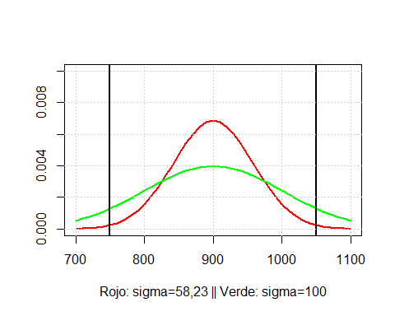

Conclusiones